29th July 2015

**Trentin maintains his lead in San Marino**

The fourth race of the Italian Trofeo Rally Terra 2015 brought more success to Mauro Trentin, the well known rally driver who is currently driving on YOKOHAMA tyres. His win at the San Marino rally places him on the very top of the TRT table.

Racing on the tough tracks of Emilia Romagna, Mauro Trentin, ably assisted as usual by co-driver Alice De Marco, on his Peugeot 207, managed to put a big gap between him and the other drivers including Gigi Ricci, also on YOKOHAMA and who this time was unfortunate to be on the losing end of a technical issue which excluded him from the race. The gap between the two drivers is now significant.

The second place on the podium was taken by Pablo Biolghini on his Skoda Fabia and also equipped with Yokohama tyres. Both pilots had equipped the YOKOHAMA ADVAN A053, which is the most reliable tyre for hard gravel surfaces.

“San Marino Rally is one of my favourites even if this year, it was particularly hard for the amount of gravel and the big stones on the track”, stated Giuseppe Pezzaioli, YOKOHAMA Italy’s Motorsport General Manager, and added “This is a true testament to our pilots’ fantastic skills and the high performance of our tyres.”

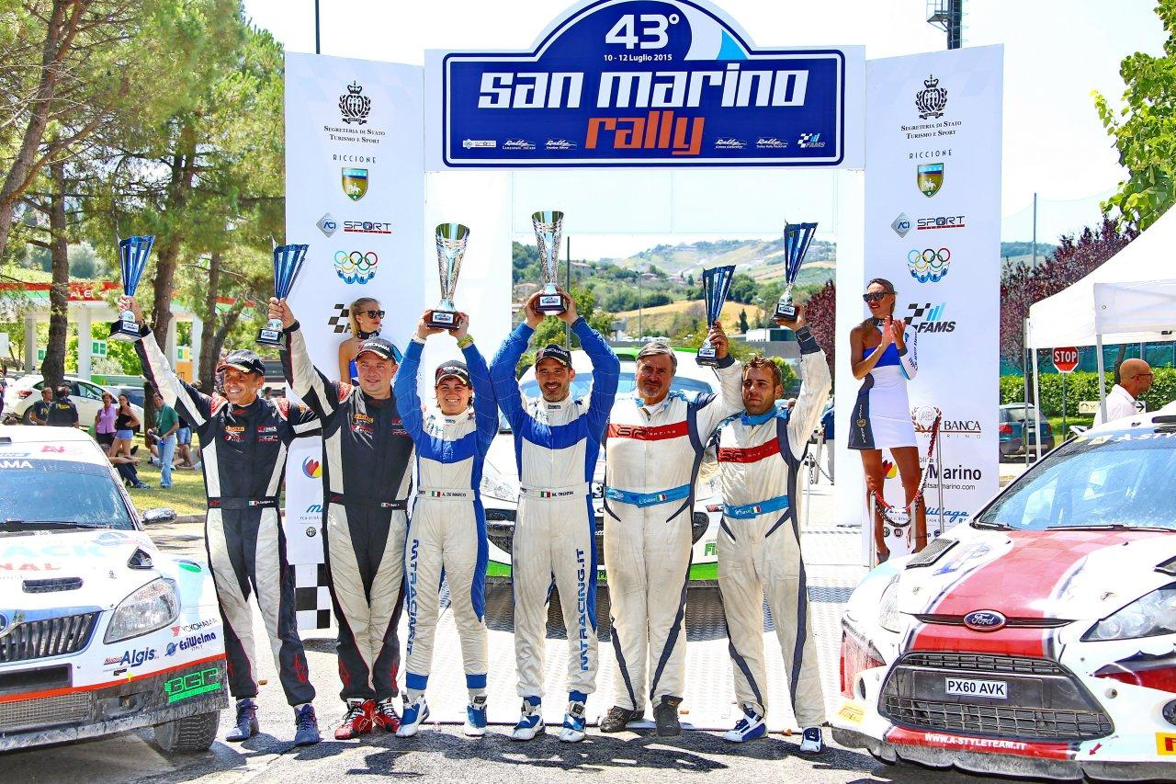 ***Mauro Trentin – Trofeo Rally Terra 2015***